Supplementary Fig. 1. The E-Z Model
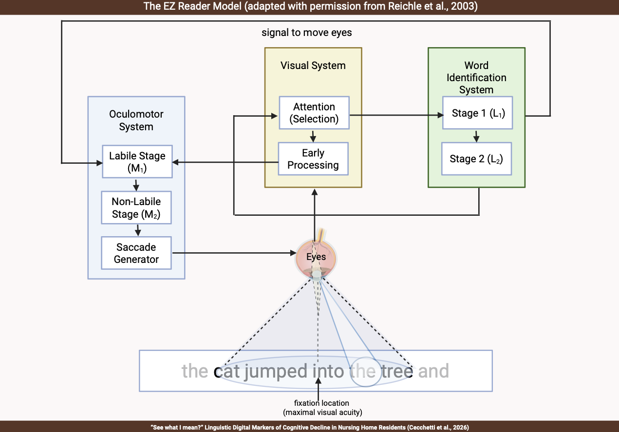
Created in BioRender. Cecchetti, S. (2026) https://BioRender.com/885uwuv

Supplementary Table 1. Questions ITA/ENG

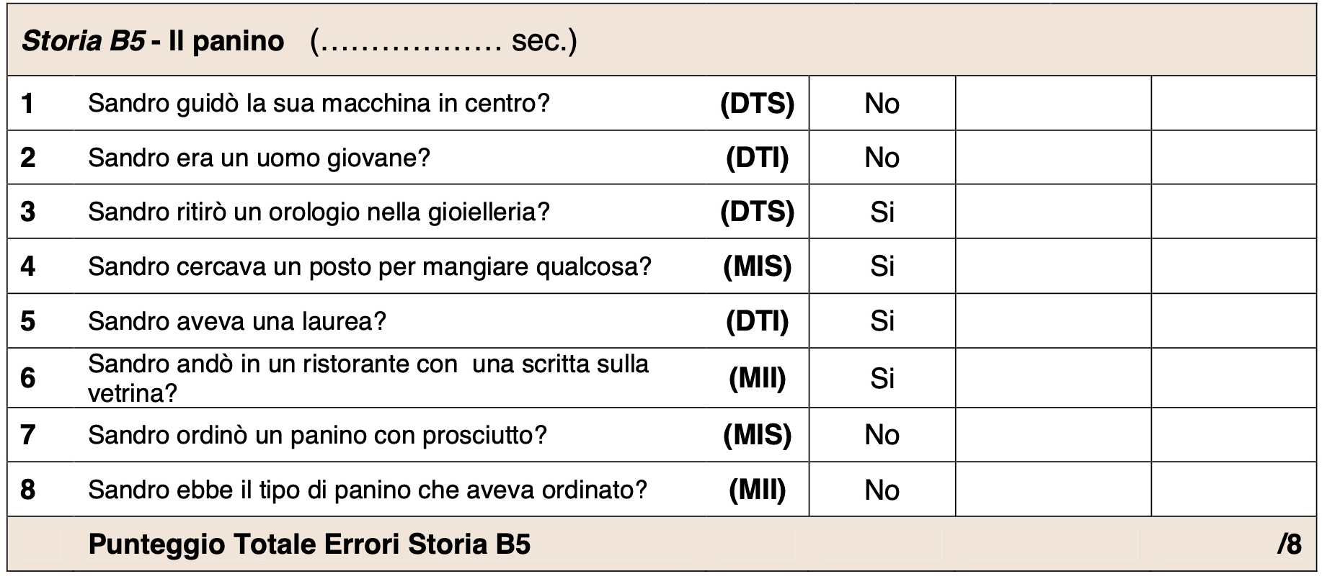

The sandwich
1 | Did Sandro drive his car to the city centre? | (DTS) | No
2 | Was Sandro a young man? | (DTI) | No
3 | Did Sandro pick up a watch at the jewellery shop? | (DTS) | Yes
4 | Was Sandro looking for a place to eat? | (MIS) | Yes
5 | Did Sandro have a degree? | (DTI) | Yes
6 | Did Sandro go to a restaurant with writing on the window? | (MII) | Yes
7 | Did Sandro order a ham sandwich? | (MIS) | No
8 | Did Sandro get the type of sandwich he ordered? | (MII) | No

Supplementary Fig. 2. AOIs

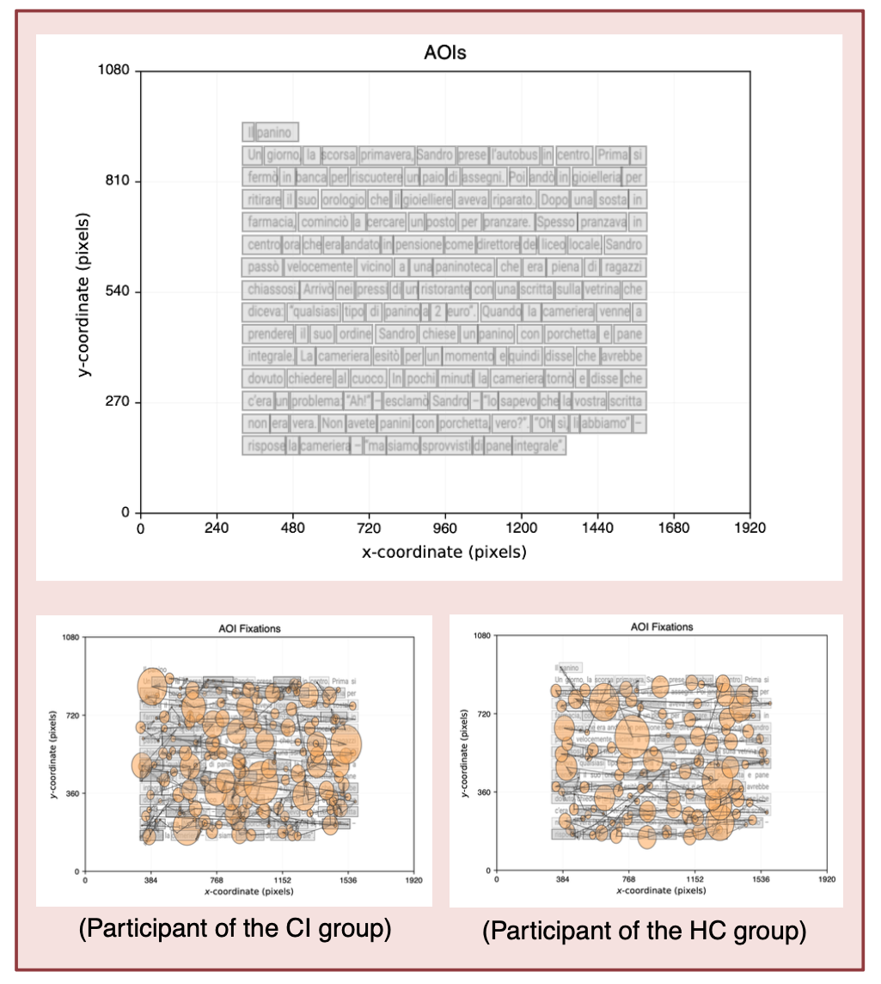

Supplementary Table 2. Shapiro-Wilk test for normality
Group | Variable | Shapiro test statistic | Shapiro test p-value
HC | Age | 0.927 | 0.041
CI | Age | 0.965 | 0.409
HC | Barthel (total) | 0.491 | 0.000
CI | Barthel (total) | 0.921 | 0.028
HC | CRI (total) | 0.983 | 0.894
CI | CRI (total) | 0.961 | 0.337
HC | Education | 0.874 | 0.002
CI | Education | 0.726 | 0.000
HC | FAB (adjusted) | 0.945 | 0.125
CI | FAB (adjusted) | 0.949 | 0.160
HC | GDS | 0.803 | 0.000
CI | GDS | 0.914 | 0.018
HC | MMSE (adjusted) | 0.978 | 0.775
CI | MMSE (adjusted) | 0.913 | 0.018
HC | RBANS total (age adjusted) | 0.903 | 0.010
CI | RBANS total  (age adjusted) | 0.948 | 0.152

Supplementary Table 3. Levene’s test for homogeneity
Variable | Numerator df | Denominator df | Leven Test statistic | Levene Test p-value
CRIq (total) | 1 | 58 | 4.185 | 0.045
FAB (adjusted) | 1 | 58 | 7.044 | 0.01

Supplementary Table 4. TRE by type
 |  | Groups
Reading Errors | Overall  N = 60 | CI  N = 30 | HC  N = 30
Mispronounced
Mean (SD) | 4.37 (6.69) | 6.40 (8.84) | 2.33 (2.09)
Median (Q1; Q3) | 3.00 (2.00; 6.00) | 5.00 (2.00; 7.00) | 2.00 (1.00; 3.00)
Min; Max | 0.00; 50.00 | 0.00; 50.00 | 0.00; 8.00
Repetitions
Mean (SD) | 1.10 (2.43) | 1.63 (3.20) | 0.57 (1.07)
Median (Q1; Q3) | 0.00 (0.00; 1.00) | 0.00 (0.00; 2.00) | 0.00 (0.00; 1.00)
Min; Max | 0.00; 13.00 | 0.00; 13.00 | 0.00; 4.00
Omissions
Mean (SD) | 13.63 (30.06) | 26.73 (38.50) | 0.53 (1.01)
Median (Q1; Q3) | 1.00 (0.00; 9.00) | 9.00 (1.00; 28.00) | 0.00 (0.00; 1.00)
Min; Max | 0.00; 132.00 | 0.00; 132.00 | 0.00; 4.00
Excess
Mean (SD) | 0.52 (1.77) | 0.80 (2.44) | 0.23 (0.50)
Median (Q1; Q3) | 0.00 (0.00; 0.00) | 0.00 (0.00; 1.00) | 0.00 (0.00; 0.00)
Min; Max | 0.00; 13.00 | 0.00; 13.00 | 0.00; 2.00
Substitutions
Mean (SD) | 2.17 (5.44) | 3.63 (7.45) | 0.70 (0.60)
Median (Q1; Q3) | 1.00 (0.00; 2.00) | 1.50 (0.00; 4.00) | 1.00 (0.00; 1.00)
Min; Max | 0.00; 41.00 | 0.00; 41.00 | 0.00; 2.00
Total Errors
Mean (SD) | 21.75 (34.11) | 39.13 (41.61) | 4.37 (3.30)
Median (Q1; Q3) | 8.00 (3.00; 22.50) | 22.50 (9.00; 47.00) | 3.00 (2.00; 7.00)
Min; Max | 0.00; 140.00 | 0.00; 140.00 | 1.00; 14.00

Supplementary Table 5. TCE by type
 |  | Groups
Characteristics | Overall  N = 60 | CI  N = 30 | HC  N = 30
Total Comprehension Errors
Mean (SD) | 2.60 (1.49) | 3.47 (1.38) | 1.73 (1.01)
Median (Q1; Q3) | 3.00 (1.00; 3.50) | 3.00 (3.00; 4.00) | 2.00 (1.00; 2.00)
Min; Max | 0.00; 8.00 | 1.00; 8.00 | 0.00; 4.00
DTS
Mean (SD) | 0.77 (0.53) | 0.87 (0.57) | 0.67 (0.48)
Median (Q1; Q3) | 1.00 (0.00; 1.00) | 1.00 (1.00; 1.00) | 1.00 (0.00; 1.00)
Min; Max | 0.00; 2.00 | 0.00; 2.00 | 0.00; 1.00
DTI
Mean (SD) | 1.03 (0.76) | 1.27 (0.64) | 0.80 (0.81)
Median (Q1; Q3) | 1.00 (0.00; 2.00) | 1.00 (1.00; 2.00) | 1.00 (0.00; 1.00)
Min; Max | 0.00; 2.00 | 0.00; 2.00 | 0.00; 2.00
MIS
Mean (SD) | 0.40 (0.59) | 0.67 (0.66) | 0.13 (0.35)
Median (Q1; Q3) | 0.00 (0.00; 1.00) | 1.00 (0.00; 1.00) | 0.00 (0.00; 0.00)
Min; Max | 0.00; 2.00 | 0.00; 2.00 | 0.00; 1.00
MII
Mean (SD) | 0.37 (0.55) | 0.60 (0.62) | 0.13 (0.35)
Median (Q1; Q3) | 0.00 (0.00; 1.00) | 1.00 (0.00; 1.00) | 0.00 (0.00; 0.00)
Min; Max | 0.00; 2.00 | 0.00; 2.00 | 0.00; 1.00

Supplementary Table 6. WPM (audio)
 |  | Groups
Characteristics | Overall  N = 60 | CI  N = 30 | HC  N = 30
WPM
Mean (SD) | 101.07 (42.15) | 75.67 (36.92) | 126.48 (30.25)
Median (Q1; Q3) | 107.30 (60.50; 136.05) | 73.95 (53.00; 106.80) | 135.10 (107.80; 146.30)
Min; Max | 14.00; 178.00 | 14.00; 142.40 | 59.30; 178.00
Reading Total Time
Mean (SD) | 115.73 (43.39) | 140.50 (40.91) | 90.97 (29.80)
Median (Q1; Q3) | 99.50 (78.50; 176.50) | 147.00 (100.00; 180.00) | 79.00 (73.00; 99.00)
Min; Max | 60.00; 180.00 | 75.00; 180.00 | 60.00; 180.00

Supplementary Fig. 3. Eye-Tracking metrics

